Task Scheduling for Maximizing Performance
and Reliability Considering Fault Recovery in Heterogeneous Distributed Systems

Chi-Yeh Chen

Abstract—Machine and network failures worsen the results of executing applications on system. Therefore, the reliability of applications on system is an important issue. The recovery of failed machines may increase processing time. This work studies the expected makespan to schedule tasks in heterogeneous distributed systems. A task may be replicated many times to reduce the expected execution time. A two-phase algorithm is proposed. The first phase uses a linear program formulation and a rounding procedure to obtain a favorable allotment to minimize the expected makespan. The second phase applies a scheduling method that is based on the expected executed time and the communication time. During execution, two strategies are considered. In the first strategy, no replication of a task on a set of processors can be stopped. In the second strategy, once a replication of a task has been completed, the other replications of the task are immediately aborted. A comparison reveals that the proposed algorithm significantly outperformed previously proposed algorithms in terms of schedule length ratio, reliability and speedup.

Index Terms—Scheduling algorithm, heterogeneous systems, reliability, precedence constraints
Ç

1 INTRODUCTION
S technology advances, powerful computers and high- speed networks become more widely used. Large-scale
A
high-performance distributed computing environments, or computational grids can be easily established, but they give rise to problems concerning quality of service (QoS) targets, including reliability, performance and throughput. An important challenge in efficiently using a parallel and dis- tributed system is to develop task scheduling algorithms. Scheduling algorithms minimize makespan and this prob- lem has been proven to be NP-Complete [10]. Therefore, solving this problem in polynomial time is difficult and effi- cient approximation heuristics are sought. In large-scale systems, machine and network failures worsen the effec- tiveness of the executed applications. Therefore, the reliabil- ity of applications is an important problem. Recently, many studies have addressed bi-criteria (makespan and reliabil- ity) multiprocessor scheduling [2], [7], [8], [11], [14], [22], [23]. The active replication of task and data communication is a common means of increasing the reliability of a system. Intuitively, adding replications increases not only reliability but also, in general, the schedule length [11].
The Local Node Fault Recovery (LNFR) mechanism sup- ports fault recovery in grid systems. If a processor fails, the failed processor is repaired or replaced; and once it becomes operational again, task execution may be resumed by a recovery action. The failures in grid systems can be

The author is with the Department of Computer Science and Information Engineering, National Cheng Kung University, No. 1, Ta-Hsueh Road, Tainan, Taiwan, ROC. E-mail: chency@csie.ncku.edu.tw.
Manuscript received 24 July 2014; revised 3 Nov. 2014; accepted 9 Feb. 2015. Date of publication 12 Feb. 2015; date of current version 20 Jan. 2016. Recommended for acceptance by D. Trystram.
For information on obtaining reprints of this article, please send e-mail to:
reprints@ieee.org, and reference the Digital Object Identifier below. Digital Object Identifier no. 10.1109/TPDS.2015.2403861

classified into two categories—unrecoverable and recover- able. Software failures that are caused by embedded faults in programs are unrecoverable. Since no recovering module can be installed on communication links, communication link failures are unrecoverable. Hardware failures can be unrecoverable or recoverable. The recoverable failures are caused by human error or performance overload. An unre- coverable hardware failure will results in the termination of the current task [13].
An application can be represented on a directed acyclic graph (DAG) in which the nodes represent tasks and the edges represent precedence constraints among tasks. Many effective heuristic scheduling algorithms have been pro- posed for DAG scheduling, including the mapping heuristic (MH) [9], the dynamic-level scheduling (DLS) algorithm [25], the levelized-min time (LMT) algorithm [18], the Criti- cal-Path-on-a-Machine (CPOP) algorithm [30], the heteroge- neous earliest-finish-time (HEFT) algorithm [28], [30] and the Dominant Sequence Clustering (DSC) algorithm [31]. Recently, a few algorithms have been proposed to minimize schedule length and increase reliability. He et al. [17] pro- posed two algorithms use in embedded heterogeneous systems. Tang et al. [27] proposed a reliability-aware sched- uling algorithm (RASD) for small-scale heterogeneous dis- tributed systems. Tang et al. [29] presented a Hierarchical Reliability-Driven Scheduling algorithm (HRDS) in a grid computing system.
Ahmad and Kwok [1] proposed a technique that system- atically decomposes the task graph into critical path node, in-branch node, and out-branch node bindings. These bind- ings help to determine the relative importance of nodes. The performance can be improved using the task duplica- tion technique, which reduces the start time of important nodes. Girault et al. [12] presented a two-step heuristic for optimizing both makespan and reliability, which adds

1045-9219 2015 IEEE. Personal use is permitted, but republication/redistribution requires IEEE permission.
See http://www.ieee.org/publications_standards/publications/rights/index.html for more information.

random replications to reach a reliability threshold, and then computes the temporal allocation function to minimize the makespan. Jeannot et al. [20] proposed an optimal scheduling algorithm whose objective is to maximize the reliability subject to makespan minimization; they also pro- vided a ð1 þ ; 1Þ-approximation algorithm of the Pareto- front. For independent arbitrary tasks, they proposed a ð2; 1Þ-approximation algorithm. Hashimoto et al. [15], [16] proposed a scheduling algorithm to realize fault tolerance in multiprocessor systems. This algorithm partitions a task graph into subsets of tasks, based on the height of a task graph. For each subset, the algorithm successively dupli- cates and the schedules the tasks in the subset. Bouguerra et al. [4] presented bi-objective scheduling algorithms for optimizing application makespan and reliability when fail- ure rates are increasing or decreasing over time.
The recovery of failures may extend the processing time. A schedule without the replication of a task may have a short makespan if no failure occurs, but with a long expected makespan. The expected makespan is reduced by properly increasing the number of replications. This work concentrates on the expected makespan. The proposed algo- rithm is a two-phase algorithm. The first phase finds a favorable number of replication of tasks. The second phase applies a scheduling method that is based on the expected executed time and the communication time.
A replication problem is herein transformed into the problem of allocating malleable tasks and the features of the expected processing time and the expected work associated with a task are analyzed, where the latter equals the total expected processing time in a multiprocessor system. An allocation method, which uses a linear program formulation and a rounding procedure to find a feasible allotment to minimize the expected makespan, is presented. A method for evaluating the expected finish time of each task and to schedule all tasks, is also developed. The experimental results reveal that the proposed algorithm significantly out- performs previously developed methods in terms of sched- ule length ratio (SLR), reliability and speedup.
The rest of this paper is organized as follows. Section 2 introduces basic definitions, notation, and assumptions. Section 3 presents the allocation method. Section 4 presents the scheduling algorithm. Section 5 summarizes experimen- tal results concerning the performance and reliability. Section 6 draws conclusions.

2 ASSUMPTIONS AND NOTATION
This work considers a heterogeneous distributed system that has many computing resources with various processing capabilities. The topology of the distributed system is mod- eled as an undirected graph GT ¼ ðP; LÞ where P repre- sents a set of m processors, that are assumed to be fully
specification, let li;i be the internal communication link in the processor pi and the weight wðli;i Þ ¼ 1.
The application is represented as a set of generic tasks, each linked to others by precedence constraints. The prece- dence constraints are first determined by analyzing the data flow among the tasks. Let G ¼ ðV; E; wÞ be a directed acyclic graph, where V ¼ fv1 ; v2 ; .. . ; vn g represents the set of tasks and E V V is the set of precedence constraints among the tasks. In a situation in which an arc ei;j ¼ ði; jÞ 2 E, task vi must be completely processed before a task vj can be executed. Task vi is called a prede- cessor of vj , and task vj is a successor of vi . The weight wðvi Þ of task vi is its computational cost and the weight wðei;j Þ of edge ei;j is its communication cost. Let Si be the set of processors that are allocated to task vi . The process- ing time of vi on processor px is denoted as tp ðvi ; px Þ ¼ wðvi Þ=wðpx Þ. The communication time of ei;j on link lk;x is denoted as tc ðei;j ; lk;x Þ ¼ wðei;j Þ=wðlk;x Þ. The com- munication time of an edge depends on the source proces- sor and the destination processor.

Definition 1. The communication time of ei;j on link lk;x is given by tc ðei;j ; lk;x Þ ¼ 0 if k ¼ x, otherwise tc ðei;j ; lk;x Þ ¼ wðei;j Þ=wðlk;x Þ .

The set of direct predecessors of task vi is represented as predðvi Þ and the set of direct successors of vi is represented as succðvi Þ. A task vi without any predecessor is called an entry task and a task without any successor is called an exit task. Without loss of generality, the DAG is assumed to have only one entry task ventry and only one exit task vexit . If multiple exit tasks or entry tasks exist, they may be con- nected with zero time-weight edges to a single pseudo-exit task or a single pseudo-entry task that has zero time-weight. Table 1 presents the notation and terminology that are used herein.

2.1 Analysis of Task Reliability
This work uses the widely accepted reliability model of Shatz and Wang [24] that the failure of processors and com- munication links in a system is assumed to follow a Poisson process and each resource is characterized by a constant failure rate per unit time . Restated, the reliability of a resource during the interval d is e d . The failure rate of pro- cessor pi is denoted as i and the failure rate of link li;j is denoted as li;j . The internal communication in a processor is considered to be failure-free, so li;i ¼ 0. Plank and Elwasif [21] demonstrate that modeling the failure of a resource by a Poisson process is a useful assumption. A fail- ure on processor pi is recoverable with a probability of g i .
The probability that communication is reliable and the
probability that it fails between vi and vj are
linked by a set of links L. An edge li;j 2 L is a bidirectional communication link between the incident processors pi and pj . The computation capacity refers to the number of opera- tions per unit time, namely, the weight wðpi Þ of processor

and
R½Eei;j ;pk ;px ¼ e
lk;x
tc ðei;j ;lk;x Þ
pi 2 P . The communication capacity refers to the data trans- fer rate, namely, the weight wðli;j Þ of edge li;j . If two tasks
are scheduled on a single processor, then the communica- tion cost between the two tasks is zero. For convenience of
F ½Eei;j ;pk ;px ¼ 1 R½Eei;j ;pk ;px ;

respectively, where task vi is executed on processor pk and the task vj is executed on processor px . The reliability
CHEN: TASK SCHEDULING FOR MAXIMIZING PERFORMANCE AND RELIABILITY CONSIDERING FAULT RECOVERY IN... 523

TABLE 1
Notation and Terminology

P , L A set of m processors and a set of links.
pi , li;j A processor and a bidirectional communication link between the incident processors pi and pj .
wðpi Þ The weight of processor pi 2 P (the number of operations per unit time.)
wðli;j Þ The weight of edge li;j (the data transfer rate.)
V , E The set of tasks and the set of precedence constraints among the tasks.
wðvi Þ The weight of task vi (computational cost.)
wðei;j Þ The weight of edge ei;j (communication cost.)
Si The set of processors that is allocated to task vi .
tp ðvi ; px Þ The processing time of vi on processor px , namely tp ðvi ; px Þ ¼ wðvi Þ=wðpx Þ.
tc ðei;j ; lk;x Þ The communication time of ei;j on link lk;x , namely tc ðei;j ; lk;x Þ ¼ wðei;j Þ=wðlk;x Þ.
predðvi Þ The set of direct predecessors of task vi .
succðvi Þ The set of direct successors of vi .
i The failure rate of processor pi .
li;j The failure rate of link li;j .
g i The probability that a failure on processor pi is recoverable.
R½Eei;j ;pk ;px The communication reliability probability between vi and vj on processor pk and processor px respectively.
F ½Eei;j ;pk ;px The communication communication failure probability between vi and vj , namely 1 R½Eei;j ;pk ;px .
R½Evi ;px The reliability probability of vi on processor px .
F ½Evi ;px The failure probability of vi on processor px .
F½Evi ;px The expected overhead of task vi on processor px .
t p ðvi Þ The mean processing time of a task vi .
t c ðei;j Þ The mean communication time of edge ei;j .
R ½Evj The mean reliability of task vj .
R ½Eei;j The mean communication reliability probability between vi and vj .
F ½Evi The mean overhead of task vi on processor px .
Fi The mean failed probability of task vi , namely Fi ¼ 1 R ½Evi .
Tp ðvi ; ai Þ The expected processing time of the task vi that executes on ai processors.
W ðvi ; ai Þ The expected work of task vi that executes on ai processors.
ALðiÞ The lower bound on the number of allotted processors for task vi .
b The weight of reliability overhead.
ESTðvi ; pk Þ The earliest start time of task vi on a processor pk .
EFTðvi ; pk ; Si Þ The earliest finish time of task vi on processor pk with other replication of tasks on a set of processors Si .
EFTðei;j ; Si ; px Þ The earliest communication finish time of edge ei;j from pk 2 Si to px .

probability of vi and the failure probability of vi on proces- sor px are

x tp vi ;px Þ
values and their mean values, respectively. In this work, the mean computational cost, mean communication cost and mean reliability are used to solve the allotment problem

and
R½Evi ;px ¼ e ð
and to compute the priorities of tasks. For a task vi
on a het-

respectively.
F ½Evi ;px ¼ 1 R½Evi ;px ;
erogeneous computing system with m processors, the mean
processing time is computed using

X wðv i Þ
m
The time of failure during the execution of a resource is
assumed to be uniformly distributed. When a resource fails,
t p ðvi Þ ¼
:
x¼1 mwðpx Þ
the expected overhead of task vi on processor px is
The mean communication time of edge ei;j is computed using
Z tp ðvi ;px Þ t
tp ðv i ;px Þ
F½Evi ;px ¼

t v ;p
dt þ upx ¼
þ upx ;
t ðe
X wðei;j Þ
Þ ¼ :
0 p ð i x Þ 2
c i;j
lx;k 2L
jLjwðlx;k Þ
where upx is the recovery time of processor px .

2.2 Normalization Step

The mean reliability of task vj is computed using
A problem for scheduling tasks on a heterogeneous com- puting system is that the processing time of tasks on a pro- cessor may differ from those of the same tasks on another
m
R ½Evj X
¼
x¼1
R½E v j ;p x :
m
processor. Therefore, the priority of tasks for the scheduling algorithm cannot be obtained. One method for solving this
The mean communication reliability probability between
vi and vj is computed using
m m 2 R½Ee i;j ;p k ;p k
problem is to normalize a heterogeneous system into a
R ½E ¼ X X
1 2
homogenous system. The DLS algorithm and the HEFT
algorithm set the computation costs of tasks to their median
ei;j

k1 ¼1 k2 ¼k1
:
mðm 1Þ

The mean overhead of task vi on processor px is
Theorem 3.2. In Strategy I, the work W ðvi ; ai Þ is non-decreasing in the number ai of allocated processors: W ðvi ; ai Þ
Z t p ðvi Þ t
t p ðvi Þ
W ðvi ; a0 Þ for ai a0 .
F ½Evi ¼

t v
dt þ up ¼
þ up ; i i
0 p ð i Þ 2
Theorem 3.3.
In Strategy I, the work
W ðv ; a Þ of a task is con-

where up is the mean recovery time of the processor.

3 ALLOTMENT PROBLEM
The recovery of failures may delay completion. Accord-
i i
vex in the expected processing time.

Proof. A function f : ½a; b ! R is convex if and only if the slope of the function is monotonically non-decreasing in
½a; b . That
ingly, this work uses a replication method to reduce the delay. This replication method executes many the same task on many processors. Two strategies, Strategy I and

W ðv i ; a i þ 1Þ W ðv i ; ai Þ
Tp ðvi ; ai þ 1Þ Tp ðvi ; ai Þ

ðv i ; a i þ 2Þ W ðv i ; ai þ 1Þ
Tp ðvi ; ai þ 2Þ Tp ðvi ; ai þ 1Þ
ai þ1
Strategy II, are considered. In Strategy I, no replication of a task can be stopped. In Strategy II, once a replication of a task is completed, the other replications of the task are immediately terminated. Restated, only one replication of a task is completed. This section solves the allotment problem for G ¼ ðV; E; wÞ without communication cost (wðei;j Þ ¼ 0)
in a homogenous system. The execution of a task is assume
for ai 1 which is equivalent to 0 1 þ Fi , must be proven. Since 0 < Fi < 1, the proof is complete. tu

3.2 Strategy II
In Strategy II, the expected work of task vi is computed as

to have to be restarted on a failed processor after the proces- sor has been recovered. Let Ep be the event that the failure of p processors. The event that p processors successively fail i times is denoted as Ep;i . The expected processing time of
task vi that is executed on ai processors is

Define
W ðvi ; ai Þ ¼ ai t p ðvi Þþ

2 F 2ai þ1
a i F a i
1 F ai
i
i
t p ðvi Þ
2 þ

ai þ1
up : (3)

ai
f1 ðvi ; ai Þ ¼

i ðai þ 1ÞFi þ ai Fi
1 2ai þ1
2 F

X
þ
ai þ1 ai
Tp ðvi ; ai Þ ¼ t p ðvi Þþ F ½Evi

k¼1
PðEai Eai ;k 1 Þ

and
i þ ðai 1ÞFi ðai þ 2ÞFi
t p ðvi Þ
X1

kai
2F ai þ1 1
F ai þ1
¼ t p ðvi Þþ
2 þ up Fi

f v ;
i i
:
k¼1
F a i t p ðvi Þ
2 ð i ai Þ ¼ 2
2ai þ2
i
F
ai þ1
i
F
¼ t p ðvi Þþ i a
þ up
; (1)
From the equation (3), the following theorems can be
1 Fi i 2

obtained.
where Fi ¼ 1 R ½Evi is the mean probability of failure of task vi . When the failure probability Fi ¼ 0, the problem is a general scheduling problem. When Fi ¼ 1, the expected

Lemma 3.4. In Strategy II,
W ðvi ; ai Þ W ðvi ; ai þ 1Þ.

up f1 ðvi ; ai Þ if and only if
tp ðvi Þ
processing time is infinite. Herein, 0 < Fi < 1 is assumed. From the equation (1), the following theorem can be obtained.
Proof (Necessary). Suppose, by contradiction, that
W ðvi ; ai Þ > W ðvi ; ai þ 1Þ which is equivalent to

t p ðvi Þ 2 þ F 2ai þ1 þ ðai 1ÞF ai þ1 ðai þ 2ÞF ai
Theorem 3.1. The expected processing time Tp ðvi ; ai Þ is strictly
decreasing in the number ai of allocated processors:
i

2ai þ1
i

ai þ1
i

ai
Tp ðvi ; ai Þ Tp ðvi ; a0 Þ , for ai a0 .
< 2up Fi ðai þ 1ÞFi þ ai Fi :
i i
2ai þ1

ai þ1 ai

3.1 Strategy I
Let Bðai ; Fi Þ be a binomially distributed random variable with parameters ai and Fi . The work of a task is the total execution time of all replicated tasks, which corresponds to the total usage of computation resources. In Strategy I, the expected work of task vi is computed as
Since up and 2 þ Fi þ ðai 1ÞFi ðai þ 2ÞFi are
t p ðv i Þ
positive in 0 < Fi < 1 and ai 1, up < f1 ðvi ; ai Þ. This
completes the proof of the contrapositive.
Sufficiency. We prove the contrapositive. Suppose

up < f1 ðvi ; ai Þ. Similarly to the necessary part, W ðvi ;
tp ðvi Þ
ai Þ > W ðvi ; ai þ 1Þ can be obtained. tu
t p ðvi Þ
Theorem 3.5. In Strategy II, if
up f1 ðvi ; ai Þ for some ai 1,
W ðvi ; ai Þ ¼ ai t p ðvi Þþ F ½Evi gðai Þ
F
W v ; a0 0 0

¼ ai t p ðvi Þþ

t p ðvi Þ
2 þ up ai
X1 k i
k¼1
ð i

Pro of.
t p ðvi Þ
i Þ W ðvi ; ai þ 1Þ for all ai ai .

Since f1 ðvi ; ai Þ is non-increasing in ai 1,
up f1 ðvi ; a0 Þ is fulfilled for all a0 ai . According to
i i
i
ai Fi t p ðvi Þ
Lemma 3.4, W ðvi ; a0 Þ W ðvi ; a0 þ 1Þ for all a0 ai .
¼ ai t p ðvi Þþ 1 F
i
2 þ up
; (2)
i
Lemma 3.6. In Strategy II, t p ðvi Þ
i
i
f v ; a
i
if and only if the
up
2 ð i i Þ
where gðai Þ ¼ Pai
k¼1
PðBðai ; Fi Þ ¼ kÞðk þ gðkÞÞ. From the
work W ðvi ; a0 Þ is convex in ½Tp ðvi ; ai þ 2Þ; Tp ðvi ; ai Þ for
equation (2), the following theorems can be obtained.
ai a0 ai þ 2.

Proof (Necessary). Suppose, by contradiction, that the work W ðvi ; a0 Þ is not convex in ½Tp ðvi ; ai þ 2Þ; Tp ðvi ; ai Þ for ai a0 ai þ 2 which is equivalent to
i
i
m and is convex in ½Tp ðvi ; mÞ; Tp ðvi ; ai þ 1Þ . An optimal solution for allotment of task vi is between ai and m. Let ALðiÞ be the lower bound on the number of allotted pro- cessors for task vi . The algorithm of allotment lower bound
t p ðvi Þ 2 F 2ai þ2 F ai þ1
< 2up F ai þ1
ai þ1
1 F
:
(Algorithm 1) determines the value of ALðiÞ. Let
i i

2ai þ2
i i

ai þ1

s ¼ f i 2 j up < f1 ðvi ;m 1Þg be the set of small tasks
V v V tp ðvi Þ
Since up and 2 Fi Fi are positive for 0 < Fi < 1
t p ðvi Þ
and Ve ¼ fvi 2 V jpredðvi Þ ¼ ;g be the set of entry tasks.
and ai 1,
up < f2 ðvi ; ai Þ. This completes the proof of
The following linear program for solving allotment prob-
the contrapositive.
Sufficiency. We prove the contrapositive. Suppose

up < f2 ðvi ; ai Þ. Similarly to the necessary part,
tp ðvi Þ

W ðv i ; a i þ 1 Þ W ðv i ; a i Þ < W ðv i ; a i þ 2 Þ W ðv i ; a i þ 1Þ
lem, based on [5], [19], must be solved.

Algorithm 1. Allorment Lower Bound
1: In the Strategy I
2: ALðiÞ ¼ 1 for all 1 i n.
Tp ðvi ; ai þ 1Þ Tp ðvi ; ai Þ
Tp ðvi ; ai þ 2Þ Tp ðvi ; ai þ 1Þ
3: In the Strategy II
4: for i 1 to n do
5: if t p ðvi Þ
can be obtained.
t p ðvi Þ
up f1 ðvi ; 1Þ then
Theorem 3.7. In Strategy II, if
up f2 ðvi ; jÞ for some j 1,
6: ALðiÞ ¼ 1.
t p ðvi Þ
the work W ðvi ; j0 Þ is convex in ½Tp ðvi ; mÞ; Tp ðvi ; jÞ for
7: else if up
< f1 ðvi ;m 1Þ then
j j0 m.

Proof. Since f2 ðvi ; jÞ is non-increasing in j 1,

up f2 ðvi ; j0 Þ is fulfilled for all j j0 m. According to
tp ðvi Þ
8: ALðiÞ ¼ m.
9: else
10: Find a number j 2 ½1;m 2 such that
tp ðvi Þ
f1 ðvi ;j þ 1Þ up < f1 ðvi ; jÞ.
Lemma 3.6, the work W ðvi ; j0 Þ is convex in ½Tp ðvi ; mÞ;
Tp ðvi ; jÞ for j j0 m. tu
t p ðvi Þ
11: ALðiÞ ¼ j þ 1.
Theorem 3.8. In Strategy II, if
up f1 ðvi ; ai Þ for some ai 1,
then the work W ðvi ; a0 Þ is convex in ½Tp ðvi ; ai þ 2Þ; Tp ðvi ; ai Þ
i
min C
for ai a0
i
ai þ 2.
s:t:
0 Ci
L; 8vi 2 V ;
Proof. We need to prove that f1 ðvi ; ai Þ f2 ðvi ; ai Þ which is equivlent to
Ci þ xk Ck; 8vi 2 V ;vk 2succðvi Þ;
Ci ¼ xi ; 8vi 2 Ve ;
xi 2 ½Tp ðvi ;mÞ; Tp ðvi ; ALðiÞÞ ; 8vi 2 V ;
ai þ1
ai þ1
ai þ2
2 ai 2Fi ai Fi þ 2Fi þ ai Fi ai Fi
v iðxi ; jÞ w^i; 8vi 2 V nVs ;j2½ALðiÞ;m 1 ;

1 F ai þ1
1

0:
w^i ¼ W ðvi; mÞ; 8vi 2 Vs ;
L C;
i¼1
Since 2ð1 F ai þ1 Þ 0, we just need to prove ai 2Fi
1
W =m ¼ Pn
w^i=m C:
ai þ1
ai þ1
ai þ2
ai Fi þ 2Fi þ ai Fi ai Fi 0 which is equivlent
to

The work function for the fractional solution is as follows:

ai þ1

v i ðx ; jÞ ¼ W ðvi ; jÞ
ai 1 þ Fi
ð1 Fi Þ
ai 2:
i
x i Tp ðv i ;jÞ

Fi 1 Fi
þ T 1
;j W vi i

Since the slope of the left hand side is positive in
0 < Fi < 1 and ai 1, it is increasing in ai 1. Thus,
p ð

for all vi 2 V n Vs .
vi Þ ð
ð ;j þ 1Þ W ðv ; jÞÞ
1 þ F 2 =Fi 2 needs to prove. Solving d ð1 þ F 2 Þ=
The rounding procedure is applied to a fractional solu-
i dFi
i tion to yield a rounded solution, as follows. Suppose that
Fi ¼ 0, the roots are Fi ¼ 1 and ð1 þ F 2 Þ=Fi has a mini-
i
mum value of 2 at Fi ¼ 1. The inequality 1 þ Fi =Fi 2
2
the optimal solution xi 2 ½Tp ðvi ;j þ 1Þ; Tp ðvi ; jÞ . If xi
Tp ðvi ;j þ 1Þ < r ðTp ðvi ; jÞ Tp ðvi ;j þ 1ÞÞ, then x is
i
is proved.
rounded to xi ¼ Tp ðvi ;j þ 1Þ; otherwise, x
is rounded to
xi ¼
i
Tp ðvi ; jÞ, where r 2 ½0; 1 is a rounding parameter.
3.3 Solving Allotment Problem
According to the analysis in Sections 3.1 and 3.2, the tasks can be mapped as malleable tasks. Accordingly, this work modifies a linear program in [5], [19] to solve the allotment
Therefore, the rounded solution xi 2 fTp ðvj ; mÞ; ... ; Tp ðvj ; ALðiÞÞg. Allotted processors a0 can be identified such
that Tp ðvi ; a0 Þ ¼ xi , yielding an allotment a0 such that a0 pro-
i
i i
vi 2 V .
cessors are allotted to job
t p ðvi Þ
According to the analysis in [5], the allotment parameter
problem. In Strategy II, if f1 ðvi ; ai þ 1Þ
up < f1 ðvi ; ai Þ for is
some ai 1, then the expected processing time Tp ðvi ; a0 Þ
i
and the expected work W ðvi ; a0 Þ
i
a0
are
strictly decreasing in
mð2 þ rÞ pﬃﬃ2ﬃﬃﬃ ﬃﬃﬃﬃﬃﬃ2ﬃﬃ rﬃﬃﬃ ﬃﬃﬃﬃﬃrﬃﬃﬃ2ﬃﬃ ﬃﬃﬃﬃﬃﬃ2ﬃﬃ ﬃﬃﬃﬃﬃﬃﬃﬃﬃﬃﬃﬃﬃﬃﬃﬃﬃﬃﬃﬃﬃﬃﬃﬃﬃﬃﬃ
1 i ai þ 1. According to Theorems 3.5, 3.7 and 3.8, the m ¼ :
ð þ þ Þm 2mð1 þ rÞ
expected work W ðvi ; a0 Þ is non-decreasing in ai þ 1 a0 2
i i
526 IEEE TRANSACTIONS ON PARALLEL AND DISTRIBUTED SYSTEMS, VOL. 27, NO. 2, FEBRUARY 2016

TABLE 2
[5] The Rounding Parameter r for 2 m 13
Definition 3. A task vi on a processor pk with replications of the task on a set of processors Si that are to be active in the interval from EST ðvi ; pk Þ to the earliest computation finish time is given by

EFTðvi ; pk ; Si Þ
F t p ðvi ;kÞ
¼ ESTðvi ; pk Þþ tp ðvi ; kÞþ 1 F
2 þ upk
where F ¼ Q

F ½Ev ;p .

The rounding parameter is

r ¼ 0:9999; for m 14

and the value of r for 2 m 13 is as given in Table 2.
The reliability-aware rank (RRank) attribute based on expected value is used herein to compute the priorities of
r2Si [fpk g i r

The earliest finish time of the communication that is asso- ciated with edge ei;j is defined as follows.

Definition 4. The earliest communication finish time of edge ei;j
from pk 2 Si to px is expressed as follows

1
X
tasks. The RRank is defined by Definition 2.
m  2 | rðmÞ  0 | m  8 | rðmÞ  0.5921
3 | 0.1198 | 9 | 0.6703
4 | 0.2290 | 10 | 0.7450
5 | 0.3293 | 11 | 0.8164
6 | 0.4225 | 12 | 0.8851
7 | 0.5098 | 13 | 0.9513

EFTðei;j ; Si ; px Þ ¼
ðEFTðvi ; pk ; Si Þ

Definition 2. Given an application DAG with n tasks and jEj
jSi j k2Si
edges, and a heterogeneous system with m processors and mðm 1Þ=2 communication links, the RRank in a particular scheduling step is a rank of a task that equals the sum of the expected computation time and the maximum value of the RRank of the successors with the communication time of the edge.

þtc ðei;j ; lk;x Þ :

A schedule is feasible if only one task is being executed by a processor at any time and if the precedence constraints EFTðei;j ; Si ; px Þ ESTðvj ; px Þ are satisfied for all vi 2
predðvj Þ. Therefore, the following two conditions [26] must
Define ai ¼ max min a0 ; m ; ALðiÞ
i
sively defined as follows:

. The RRank is recur-

ai

be satisfied for all tasks in the DAG.

Condition 1 (The processor constraint). For any task
RRankðvi Þ ¼ Tp ðvi ; ai Þ 1 þ bð1 R i Þ
vi ; vj 2 V that is performed by a processor p 2 P ,

where
þ max
vj 2succðvi Þ
t c ðei;j Þþ RRankðvj Þ :
EFTðvi ; p; Si Þ ESTðvj ; pÞ or EFTðvj ; p; Sj Þ ESTðvi ; pÞ.

Condition 2 (The precedence constraint). For any edge
ei;j 2 E, vi ; vj 2 V , ESTðvj ; px Þ EFTðei;j ; Si ; px Þ.

vj 2 V on
R i ¼ ðPfno failure occursg
X1
From Condition 2, the earliest start time of task
a processor px 2 P is constrained by the entering edges of
vj , and is called the data ready time (DRT).
þ
k¼1
Pfk recoverable failures occurring,

DRT v ;p

max

EFT e

;S ;p :
vi is completedgÞ
ð j x Þ ¼ e
i;j 2E;vi 2
predðvj Þ
ð i;j
i x Þ
a
1 1 R E k
½ ek;i
Y

From Conditions 1 and 2, the earliest start time of task
vk 2predðvi Þ
¼ R ½Evi X 1 R ½Evi g
1
vj on a processor px 2
P is expressed as follows

k

k¼0
ESTðvj ; px Þ ¼ max DRTðvj ; px Þ; Availableðvj ; px Þ ;
Y

vk 2predðvi Þ
a
½ ek;i
1 1 R E k

where Availableðvj ; px Þ is the time available for task vj on
ak
processor px .
R ½Evi
¼ 1 g þ g R ½Ev
i
Y 1
vk 2predðvi Þ
1 R ½Eek;i ;

4.1 The Proposed Algorithm

b is the weight of the reliability overhead and g ¼
k¼1 g k =m is the mean probability that a failure on proces- sor is recoverable.
Pm

4 MAKESPAN PROBLEM
A schedule of a DAG is specified by a starting time and a set of processors that are allocated to every task. Let ESTðvi ; pk Þ be the earliest start time of task vi 2 V on a processor pk 2 P . The earliest finish time of task vi on processor pk is defined as follows.
This section presents a heterogeneous allotment-aware scheduling algorithm, heterogeneous allotment-aware scheduling algorithm (HAAS), in a heterogeneous distrib- uted system. The classic scheduling algorithm with duplica- tion replicates a predecessor of the task to reduce the earliest finish time of that task. A replication method is used herein to reduce the expected processing time. The algo- rithm utilizes a linear program to obtain an allotment a0 . A novel allotment a that is obtained from the resulting allot- ment a0 , the allotment parameter m and the lower bound of allotment ALðiÞ. Let
CHEN: TASK SCHEDULING FOR MAXIMIZING PERFORMANCE AND RELIABILITY CONSIDERING FAULT RECOVERY IN... 527

Lðvj ; pk ; Sj Þ ¼ EFTðvj ; pk ; Sj Þ
þ bð1 Rj Þtp ðvj ; kÞ
b ð1 R j ÞF tp ðvj ; kÞ
which is with the minimum earliest finish time. The objec- tive function of GPFA is chosen as the bi-objective aggrega- tion-based heuristic [20]. The HRDS algorithm uses a ready
þ 1 F
2 þ upk
task set Q from a scheduling list and chooses a task in Q to
schedule greedily. The latter method improves the perfor-
be the sum of the task reliability overhead and the earliest finish time of task vj on processor pk , where

R½E v j
mance of all algorithms, but influences the comparison thereof. To avoid this occurrence, jQj ¼ 1 is set.
In testing the algorithms, two sets of graphs, which corre-
spond to randomly generated application graphs and paral-
Rj ¼ 1 g
þ g R½E
lel numerical application graphs for real-world problems,
k k vj
Y 1 Y
!
F ½Eei;j ;px ;pk
are considered. To simulate the recovery of resources, the following random procedure (Algorithm 3) is used to deter-

and F ¼ Q
vi 2predðvj Þ

F ½Ev ;p .
px 2Si
mine the execution time of a task. The failure rates of pro-
cessors and links are assumed to be uniformly distributed between 1 10 3 and 1 10 2 failures per unit time [30].
r2Sj [fpk g j r
In a previous work [5], malleable tasks were scheduled
on a homogenous computing system. All processors that execute a malleable task must start and finish simulta- neously. Since a heterogeneous computing system is consid- ered herein, a strategy for choosing a favorable processor is required (Algorithm 2: lines 10-12.) Since the replicated tasks do not have to be started simultaneously, the solution a is an upper bound on the number of allotted processors. The algorithm replicates a task until no replication of the task can improve the makespan, or the number of tasks is a (Algorithm 2: lines 8, 13-17.)

Algorithm 2. The Allotment-aware Scheduling
1: Normalize the heterogeneous system into a homogenous system.
2: Compute allotment parameter a0 by the linear
program and the rounding procedure.
3: Compute ai ¼ max minfa0 ; mg; ALðiÞ for vi 2 V .
i
4: Compute RRank for all tasks by traversing graph
frome the exit task.
5: Sort the tasks in a scheduling list by non-increasing order of RRank
6: while the scheduling list is not empty do
7: Remove the first task vi from the scheduling list and set
Si ¼ ; and CT ¼ 1.
8: while ai > jSi j do

Algorithm 3. The Expected Time Procedure
1: Compute the reliability probability R ¼ e tp ðv;pÞ
for the task v on the processor p and set t ¼ tp ðv; pÞ.
2: Get a number n 2 ½0; 1 uniformly at random.
3: while n > R do
4: Get a number p 2 ½0; 1 uniformly at random.
5: t ¼ t þ p tp ðv; pÞþ u
6: Get a number n 2 ½0; 1 uniformly at random.

5.1 Comparison Metrics
The algorithms are compared using the following metrics.

Schedule length ratio [30]. The main performance mea- sure of a scheduling algorithm on a graph is the schedule length (makespan) of its output schedule. Since a large set of task graphs with different proper- ties is used, it is necessary to normalize the schedule length to a lower bound, which is called the Schedule length ratio. The SLR value of an algorithm on a graph is defined by
makespan
SLR :
¼ P
vi 2CPmin minpj 2P tc ðvi ; pj Þ
9: Set Lmin ¼ 1 and pc ¼ null
10: for each pk 2 P n Si do
11: if Lmin > Lðvi ; pk ; Si Þ and CT > EFTðvi ; pk ; Si Þ
then
12: Set pc ¼ pk and Lmin ¼ Lðvi ; pk ; Si Þ
13: if pc ¼ null then
14: Si ¼ Si [ fpc g
15: CT ¼ maxpx 2Si fEFTðvi ; px ; Si Þg
16: else
17: No replication of task can improve the makespan and breaks the while-loop.

5 EXPERIMENTAL RESULTS
CPmin is the critical path of the DAG. The denomina-
tor is the time of critical path that executes on the
fastest processor. The SLR of a graph (using any algorithm) cannot be less than one since the denomi- nator is the lower bound. The task-scheduling algo- rithm that gives the lowest SLR of a graph is the best algorithm with respect to performance. The mean SLR values over several task graphs are used in our simulation experiments.
Speedup. The speedup value for a given graph is com- puted by dividing the expected sequential execution time by the parallel execution time,

minp P P o
n

This section compares the performance of the HAAS algo- rithm to that of three well-known scheduling algorithms— the HEFT [30], HRDS [29] and GPFA [20] algorithms. The cost function of HEFT is the earliest finish time of a task

Speedup ¼

where
j 2 v i 2V T ðv i ;pj Þ
;
makespan

1 e j tp ðv i ;p j Þ tp ðv i ;pj Þ
without considering the reliability for a processor. HEFT uses
the cost function to choose a favorable processor for a task
T ðvi ; pj Þ ¼ tp ðvi ; pj Þþ

e j tp ðvi ;pj Þ
2 þ upj :

Reliability probability. In the section 2.1, the reliability probability of tasks is independent on those of edges. However, to evaluate the application reliability prob- ability, the reliability probability of edges are influ- enced those of tasks. To improve discrimination between the definition of Section 2.1 and the evalua- tion of application reliability probability, let P½Evi ;px denote the application reliability probability of vi exe- cuted on processor px . Since Strategy II aborts other
replication of tasks, the reliability probability is dependent on which processor has completed task. Let Ci denote a set of processors which has completed task vi . The application reliability probability of vj is

P½Evj ;pk ¼ ðPfno failure occursg
X1
þ Pfk recoverable failures
the rounding it up to the nearest integer [30]. A dense graph can be generated by selecting a 1:0 and a low a value leads to a DAG with a low paral- lelism degree [3], [27].
Computational cost heterogeneity factor, (h) [6]. A high h value indicates high variance of the computational costs of a task, with respect to the processors in the system, and vice versa. If the heterogeneity factor is set to 0, the computational cost of a task is the same for all processors. The mean computational cost of a
task wðvi Þ is randomly generated using a uniform distribution generator with a mean value of W . The value of W does not affect the performance results of the scheduling algorithms. If there are m processors in a heterogeneous distributed systems, the compu- tational cost of a task vi for each node is set by ran- domly selecting m computational cost values of
k¼1
v from the range w v
1 h ; w v
1 h .
i ½ ð i Þ ð
2Þ
ð i Þ ð þ 2Þ
. occurring; vj is completedgÞ
Y
Let leveli
be the level of task vi
and Lvðvi Þ ¼ fvj 2

vi 2predðvj Þ
Reðei;j ; pk Þ
V jleveli < levelj g be a set of tasks that have a higher level
than vi . In the construction of an acyclic DAG, only a subset
X1 i
of Lvðvi Þ can be chosen as successors of each task vi . For the
¼ R½Evj ;pk
Y

i¼0
1 R½Evj ;pk g k
task vi , a set of successors is randomly chosen with a proba- bility of d . Let W be the mean weight of a task. Task
j ð i Þj
Lv v
Reðei;j ; pk Þ
weights are generated randomly with a uniform distribu-
vi 2predðvj Þ
tion in ½1; 2W
1 . Edge weights are generated with a uni-
R½E v j ;p k
¼ 1 gk þ g k R½Evj ;pk
Y
form distribution ½1; 2CCR W 1 . Therefore, the various types of applications that are related to CCR and W can be constructed. The frequency of the processor (the number of

where

vi 2predðvj Þ
Reðei;j ; pk Þ
unit times per operation) and the frequency of the link (the number of unit times per data) are randomly determined
with a uniform distribution in ½1 h ; 1 þ h . Therefore, the
2 2
Reðei;j ; pk Þ ¼ 1 Y
1 R½Eei;j ;px ;pk :
expected processing time of a task
vi at each node is in the
px 2Ci
range ½wðvi Þ ð1 hÞ; wðvi Þ ð1 þ hÞ . This experiment
2 2
assumes that the recovery time depends on the capacity of
The application reliability probability is defined as
the processor. The recovery times up i

follows

P½G ¼ Y

!
1 Y 1 P½Ev ;p :

i ¼ 1=wðp Þ for all pro-
cessor pi 2 P . The probability g i , that a failure on processor
pi is recoverable, is obtained randomly and uniformly dis-
tributed in ½0:5; 0:9 for all processors pi 2 P .

vi 2V
i x
px 2Si

5.3 Random Application Performance Results
5.2 Randomly Generated Application Graphs
This section first considers a set of randomly generated application graphs that is formed with a set of fundamental characteristics.

DAG size, n. The number of tasks in the application
DAG.
Communication to computation cost ratio, CCR. The mean communication cost divided by the mean com- putation cost of the application DAG.
Out degree, d. Out degree of a task node.
Parallelism factor, (a) [6]. The number of levels of the application DAG is calculated by randomly generat- ing a number, using a uniform distribution with a
pﬃn ﬃ
mean value of a , and then rounding it up to the
nearest integer. Also, the width of each level is calcu-

lated by randomly generating a number using a uni- form distribution with a mean value of a pﬃnﬃﬃ and
In this section, each data point is the mean of data obtained in 1,000 experiments. Let HAAS1 be the proposed algorithm that implements Strategy I; HAAS2 be the proposed algo- rithm that implements Strategy II and HAAS3 be the pro- posed algorithm with ai ¼ 1 for all vi 2 V .
Figs. 1, 2, and 3 present numerical results concerning the
SLR, reliability and speedup for various CCR values. Graphs are generated from W ¼ 30;h ¼ 0:5; a ¼ 1;d ¼ 3 and the number of tasks between 40 and 200, in steps of 40. The weight of the reliability overhead b is zero. Figs. 1, 2, and 3 reveal that HAAS significantly outperforms HEFT, HRDS and GPFA in terms of the SLR, reliability and speedup. The SLR, reliability and speedup that are generated using the algorithms with computation-intensive applications (CCR ¼
0.1) indicate that HAAS2 outperforms other algorithms except HAAS3 in case of a large application with n 160.
For communication-intensive applications (CCR ¼ 3), HAAS3 significantly outperforms other algorithms in terms

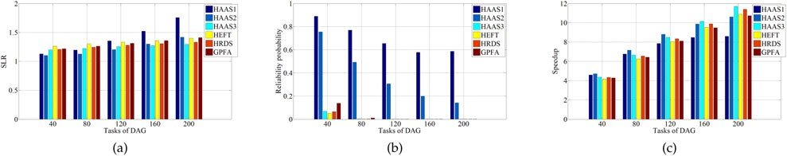

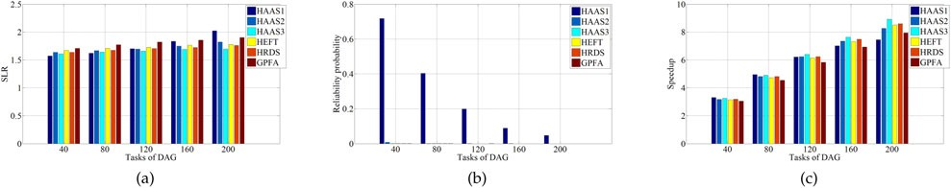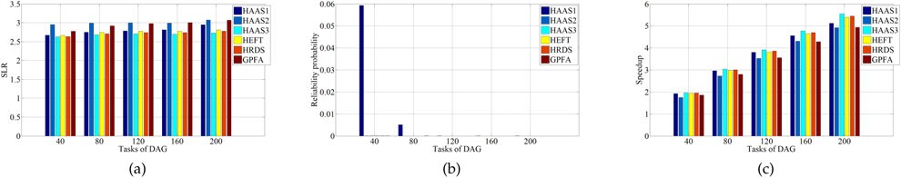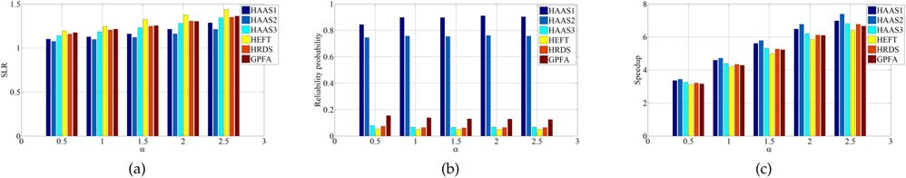Fig. 1. SLR, Reliability probability and Speedup of HAAS, HRDS, HEFT and GPFA algorithms for CCR ¼ 0.1. Fig. 2. SLR, Reliability probability and Speedup of HAAS, HRDS, HEFT and GPFA algorithms for CCR ¼ 1. Fig. 3. SLR, Reliability probability and Speedup of HAAS, HRDS, HEFT and GPFA algorithms for CCR ¼ 3.
Fig. 4. SLR, Reliability probability and Speedup of HAAS, HRDS, HEFT and GPFA algorithms for CCR ¼ 0.1 and DAG size ¼ 40.

of the SLR and the speedup, mainly because the communi- cation dominates the other terms in the performance. Since the proposed algorithm solves the allotment problem with- out communication cost, the replication of a task cannot improve the makespan. In Strategy I, no replication of a task can be stopped, then it has many replication of edge to reduce the communication time. Therefore, Strategy I out- performs Strategy II.
In the computation-intensive applications (CCR 1), the slope of speedup in HAAS3 exceeds the slope of speedup in HAAS1 and HAAS2 because the processors are too few. The following brief conclusion can be drawn. HAAS3 per- forms better when the ratio n=m or CCR is larger. Strategy I is preferred for communication-intensive applications and Strategy II is preferred for computation-intensive applica- tions. The proposed algorithm using Strategy I outperforms the other algorithms in terms of reliability.
A second set of experiments on the graph structure is considered. The parallelism factor a is set from 0.5 to 2.5. Fig. 4 reveals that HAAS significantly outperforms the other algorithms in terms of the SLR, reliability and speedup. Since highly parallel applications can be parallelized effec- tively in a multiprocessor system, the performance increases significantly as the parallelism factor a increases.
A third set of experiments are performed on the hetero- geneity factors h that between zero to one. Fig. 5 reveals that HAAS2 outperforms HEFT, HRDS and GPFA in terms of the SLR, reliability and speedup when h 0:75. When h ¼ 1, HAAS3 outperforms HEFT, HRDS and GPFA in terms of the SLR, reliability and speedup. HAAS1 and HAAS2 perform better at a lower heterogeneity factor.
A fourth set of experiments are performed on the weight of reliability overhead b. A trade-off between the performance and reliability is made using b. Fig. 6 reveals that HAAS with

Fig. 5. SLR, Reliability probability and Speedup of HAAS, HRDS, HEFT and GPFA algorithms for various heterogeneity factors h.

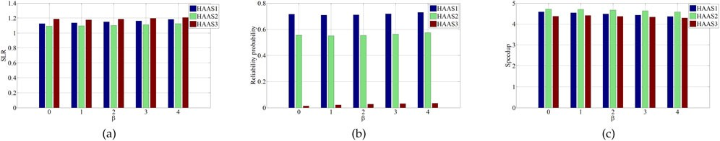

Fig. 6. SLR, Reliability probability and Speedup of HAAS for various weights of reliability overhead b where gi 2 ½0:1; 0:5 .

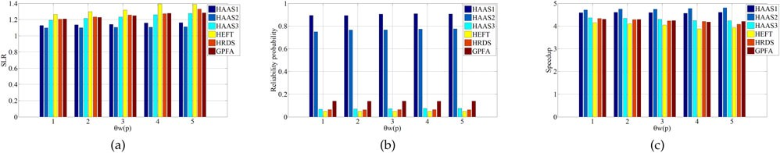

Fig. 7. SLR, Reliability probability and Speedup of HAAS, HRDS, HEFT and GPFA algorithms for various recovering time u.

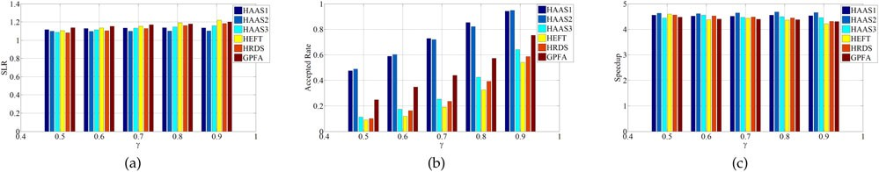

Fig. 8. SLR, Accepted rate and Speedup of HAAS, HRDS, HEFT and GPFA algorithms for various g.

a higher b has a greater reliability than HAAS with a lower b. However, the performance becomes worse as b increases.
A fifth set of experiments are performed on the recovery time. Fig. 7 reveals that SLR increases with the recovery time. Recovery time affects the speedup of HEFT, HRDS and GPFA but not that of HAAS.
A sixth set of experiments are performed on the probabil- ity g . In these experiments, a processor may fail and cannot recover. Therefore, scheduling may not be completed. This experiment concerns another important metric that is the accepted rate of scheduling (the number of successful schedules/the total number of schedules). Fig. 8b reveals that the accepted rate increases with g . Moreover, Fig. 8 reveals that HAAS2 outperforms HEFT, HRDS and GPFA in terms of the SLR, accepted rate and speedup.
A seventh set of experiments are performed on the size of Q. Appendix A, which can be found on the Computer Soci- ety Digital Library at http://doi.ieeecomputersociety.org/
10.1109/TPDS.2015.2403861 available online, presents the pseudocode of the local search method associated with the proposed algorithm. Fig. 9 reveals that the local search method cannot greatly improve the performance of algo- rithms. HAAS significantly outperforms the other three in terms of the SLR, the reliability and the speedup.

5.4 Regular Application Graphs
This section evaluates the performance of the scheduling algorithms in three real-world parallel problems: Gaussian elimination, fast Fourier transform and a molecular dynam- ics code [6].

5.4.1 Gaussian Elimination
In the experiments on the Gaussian elimination application, CCR ¼ 0.1 and the computation cost heterogeneity factor h was fixed. Since the structure of the application graph is

Fig. 9. SLR, Reliability probabilityand Speedup of HAAS, HRDS, HEFT and GPFA algorithms for various size of Q.

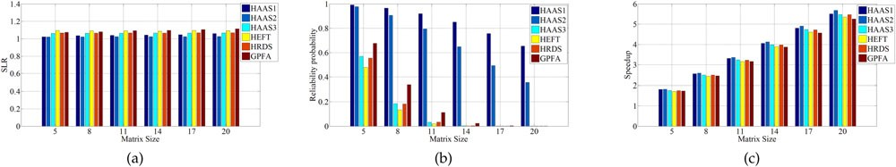

Fig. 10. SLR, Reliability probability and Speedup of HAAS, HRDS, HEFT and GPFA algorithms for the Gaussian elimination graph.

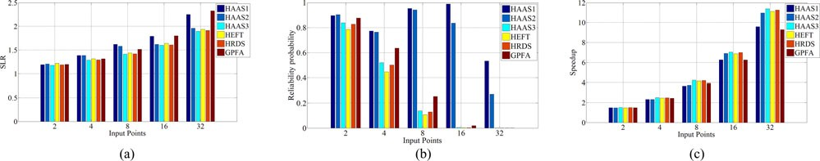

Fig. 11. SLR, Reliability probability and Speedup of HAAS, HRDS, HEFT and GPFA algorithms for the FFT graph.

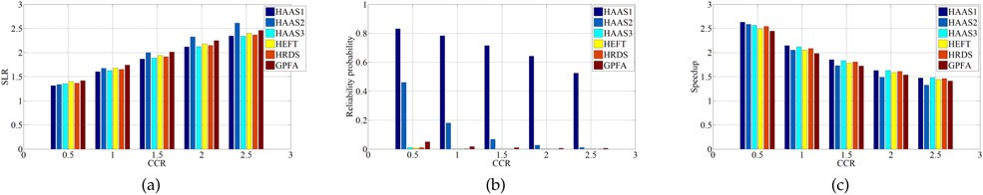

Fig. 12. SLR, Reliability probability and Speedup of HAAS, HRDS, HEFT and GPFA algorithms for the task graph of a molecular dynamics code.

known, the other parameters related to the graph structure are not required. A new parameter, matrix size (Z), is used instead of DAG size n (the number of tasks in the DAG graph). The total number of tasks in a Gaussian elimination graph is Z 2 þZ 2 [30].
2
Fig. 10 presents the SLR, reliability and speedup of algo- rithms with various matrix sizes from 5 to 20 in increments of three, with the number of processors set to 32. As the matrix size increases, more tasks are not on the critical path, improving the performance of each algorithm. The HAAS2 significantly outperforms the HRDS, HEFT and GPFA algo- rithms in terms of the SLR, reliability and speedup.

5.4.2 Fast Fourier Transformation (FFT)
The recursive, one-dimensional FFT algorithm and its task graph can be found elsewhere [27], [30]. The FFT algorithm with an input vector of size Z has 2Z 1 recursive call tasks and Z log Z butterfly operation tasks. In the experiments on FFT applications, the CCR and the computational cost
heterogeneity factor h were fixed. The numbers of data points in FFT are powers of two from 2 to 32.
Fig. 11 reveals that HAAS3 outperforms HEFT, HRDS
and GPFA in terms of the SLR, reliability and speedup. The slope of speedup in HAAS3 exceeds the slop of speedup in HAAS1 and HAAS2.

5.4.3 Molecular Dynamics Code
The task graph of a modified molecular dynamic code can be found elsewhere [30]. Since the structure of the applica- tion graph is known, only the values of CCR and the computational cost heterogeneity factor h are used to simu- late. The CCR is increased from 0.5 to 2.5 in steps of 0.5.
Fig. 12 reveals that HAAS outperforms the other algo- rithms in terms of the SLR, reliability and speedup. As CCR increases, the performance of the algorithms becomes worse. The HAAS1 outperforms HRDS, HEFT and GPFA in terms of the SLR, reliability and speedup. When CCR is at least two, HAAS3 outperforms the other algorithms in terms of the SLR and speedup.
532 IEEE TRANSACTIONS ON PARALLEL AND DISTRIBUTED SYSTEMS, VOL. 27, NO. 2, FEBRUARY 2016

6 CONCLUDING REMARKS
This work considers the expected makespan to schedule tasks in heterogeneous distributed systems. A heteroge- neous allotment-aware scheduling algorithm is proposed. The algorithm is a two-phase algorithm. In the first phase, a favorable allotment is determined using a linear program formulation and a rounding procedure. In the second phase, a scheduling method that is based on the expected execu- tion time and the communication time is implemented.
Two strategies I and II are considered. In Strategy I, no rep- lication of a task can be stopped. In Strategy II, once a replica- tion of a task is completed, the other replications of a task are immediately aborted. Strategy I is preferred for communica- tion-intensive applications and Strategy II is preferred for computation-intensive applications. According to an experi- mental study in which a set of randomly generated applica- tion graphs and application graphs of three real-world problems (Gaussian elimination, FFT, and a molecular dynamics code) were used, the HAAS algorithm significantly outperformed the other algorithms in terms of the SLR, reli- ability and speedup.

ACKNOWLEDGMENTS
C.-Y. Chen is the corresponding author.

REFERENCES
[1] I. Ahmad and Y.-K. Kwok, “On exploiting task duplication in parallel program scheduling,” IEEE Trans. Parallel Distrib. Syst., vol. 9, no. 9, pp. 872–892, Sep. 1998.
[2] I. Assayad, A. Girault, and H. Kalla, “A bi-criteria scheduling heu- ristic for distributed embedded systems under reliability and real- time constraints,” in Proc. Int. Conf. Dependable Syst. Netw., Jun.
2004, pp. 347–356.
[3] S. Bansal, P. Kumar, and K. Singh, “An improved duplication strategy for scheduling precedence constrained graphs in multiprocessor systems,” IEEE Trans. Parallel Distrib. Syst., vol. 14, no. 6, pp. 533–544, Jun. 2003.
[4] M. S. Bouguerra, D. Kondo, F. Mendonca, and D. Trystram,
“Fault-tolerant scheduling on parallel systems with non- memoryless failure distributions,” J. Parallel Distrib. Comput., vol. 74, no. 5, pp. 2411–2422, 2014.
[5] C.-Y. Chen and C.-P. Chu, “A 3.42-approximation algorithm for scheduling malleable tasks under precedence constraints,” IEEE Trans. Parallel Distrib. Syst., vol. 24, no. 8, pp. 1479–1488, Aug. 2013.
[6] M. I. Daoud and N. Kharma, “A high performance algorithm for
static task scheduling in heterogeneous distributed computing systems,” J. Parallel Distrib. Comput., vol. 68, no. 4, pp. 399–409,
2008.
[7] A. Dogan and F. Ozguner, “Matching and scheduling algorithms for minimizing execution time and failure probability of applica- tions in heterogeneous computing,” IEEE Trans. Parallel Distrib.
Syst., vol. 13, no. 3, pp. 308–323, Mar. 2002.
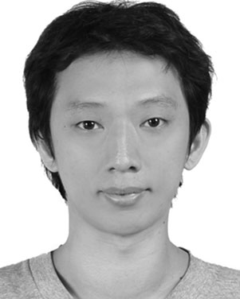[8] A. Dogan and F. Ozguner, “Biobjective scheduling algorithms for execution time-reliability trade-off in heterogeneous computing systems,” Comput. J., vol. 48, no. 3, pp. 300–314, 2005.
[9] H. El-Rewini and T. Lewis, “Scheduling parallel program tasks onto arbitrary target machines,” J. Parallel Distrib. Comput., vol. 9, no. 2, pp. 138–153, 1990.
[10] M. R. Garey and D. S. Johnson, Computers and Intractability: A Guide to the Theory of NP-Completeness. San Francisco, CA, USA; Freeman, 1979.
[11] A. Girault and H. Kalla, “A novel bicriteria scheduling heuristics providing a guaranteed global system failure rate,” IEEE Trans. Dependable Secure Comput., vol. 6, no. 4, pp. 241–254, Oct. 2009.
[12] A. Girault, E rik Saule, and D. Trystram, “Reliability versus perfor- mance for critical applications,” J. Parallel Distrib. Comput., vol. 69, no. 3, pp. 326–336, 2009.
[13] S. Guo, H.-Z. Huang, Z. Wang, and M. Xie, “Grid service reliabil- ity modeling and optimal task scheduling considering fault recov- ery,” IEEE Trans. Rel., vol. 60, no. 1, pp. 263–274, Mar. 2011.
[14] M. Hakem and F. Butelle, “A bi-objective algorithm for scheduling parallel applications on heterogeneous systems subject to fail-
ures,” in Proc. RenPar, 2006, pp. 25–35.
[15] K. Hashimoto, T. Tsuchiya, and T. Kikuno, “A new approach to realizing fault-tolerant multiprocessor scheduling by exploiting implicit redundancy,” in Proc. 27th Annu. Int. Symp. Fault-Tolerant Comput. Digest Papers., Jun. 1997, pp. 174–183.
[16] K. Hashimoto, T. Tsuchiya, and T. Kikuno, “Effective scheduling
of duplicated tasks for fault tolerance in multiprocessor systems,”
IEICE Trans. Inform. Syst., vol. 85, no. 3, pp. 525–534, 2002.
[17] Y. He, Z. Shao, B. Xiao, Q. Zhuge, and E. Sha, “Reliability driven task scheduling for heterogeneous systems,” in Proc. 15th IASTED Int. Conf. Parallel Distrib. Comput. Syst., 2003, vol. 1, pp. 465–470.
[18] M. A. Iverson, F. O€ zgu€ner, and G. J. Follen, “Parallelizing existing
applications in a distributed heterogeneous environment,” in
Proc. 4TH Heterogeneous Comput. Workshop, 1995, pp. 93–100.
[19] K. Jansen and H. Zhang, “Scheduling malleable tasks with prece- dence constraints,” J. Comput. Syst. Sci., vol. 78, no. 1, pp. 245–259,
2011.
[20] E. Jeannot, E. Saule, and D. Trystram, “Optimizing performance and reliability on heterogeneous parallel systems: Approximation
algorithms and heuristics,” J. Parallel Distrib. Comput., vol. 72, no. 2, pp. 268–280, 2012.
[21] J. Plank and W. Elwasif, “Experimental assessment of workstation failures and their impact on checkpointing systems,” in Proc. 28th Annu. Int. Symp. Fault-Tolerant Comput., Jun. 1998, pp. 48–57.
[22] P. Pop, K. H. Poulsen, V. Izosimov, and P. Eles, “Scheduling and voltage scaling for energy/reliability trade-offs in fault-tolerant
time-triggered embedded systems,” in Proc. 5th IEEE/ACM Int. Conf. Hardware/Softw. Codesign Syst. Synthesis, 2007, pp. 233–238.
[23] X. Qin and H. Jiang, “A novel fault-tolerant scheduling algorithm for precedence constrained tasks in real-time heterogeneous sys- tems,” Parallel Comput., vol. 32, no. 5, pp. 331–356, 2006.
[24] S. Shatz and J.-P. Wang, “Models and algorithms for reliability-
oriented task-allocation in redundant distributed-computer sys- tems,” IEEE Trans. Rel., vol. 38, no. 1, pp. 16–27, Apr. 1989.
[25] G. C. Sih and E. A. Lee, “A compile-time scheduling heuristic for interconnection-constrained heterogeneous processor architectures,” IEEE Trans. Parallel Distrib. Syst., vol. 4, no. 2, pp. 175–187, Feb. 1993.
[26] O. Sinnen, L. Sousa, and F.-E. Sandnes, “Toward a realistic task
scheduling model,” IEEE Trans. Parallel Distrib. Syst., vol. 17, no. 3, pp. 263–275, Mar. 2006.
[27] X. Tang, K. Li, R. Li, and B. Veeravalli, “Reliability-aware scheduling strategy for heterogeneous distributed computing sys- tems,” J. Parallel Distrib. Comput., vol. 70, no. 9, pp. 941–952, 2010.
[28] X. Tang, K. Li, and D. Padua, “Communication contention in APN
list scheduling algorithm,” Sci. China Series F: Inform. Sci., vol. 52, no. 1, pp. 59–69, 2009.
[29] X. Tang, K. Li, M. Qiu, and E. H.-M. Sha, “A hierarchical reliabil- ity-driven scheduling algorithm in grid systems,” J. Parallel Dis- trib. Comput., vol. 72, no. 4, pp. 525–535, 2012.
[30] H. Topcuoglu, S. Hariri, and M.-Y. Wu, “Performance-effective
and low-complexity task scheduling for heterogeneous computing,” IEEE Trans. Parallel Distrib. Syst., vol. 13, no. 3, pp. 260–274, Mar. 2002.
[31] T. Yang and A. Gerasoulis, “DSC: Scheduling parallel tasks on an unbounded number of processors,” IEEE Trans. Parallel Distrib. Syst., vol. 5, no. 9, pp. 951–967, Sep. 1994.

Chi-Yeh Chen received the BS degree in com- munication engineering from Da-Yeh University, Changhua, Taiwan, ROC, in 2001, and the MS degree in computer science and information and engineering from National Cheng Kung Univer- sity, Tainan, Taiwan, ROC, in 2005, and the PhD degree in computer science and information and engineering from National Cheng Kung Univer- sity, Tainan, Taiwan, ROC, in 2012. He is cur- rently an assistant researcher in the Department of Computer Science and Information Engineer-
ing, National Cheng Kung University, Taiwan, ROC. His research inter- ests include scheduling problems, approximation algorithms, parallel algorithm and load distribution.

